Cairo University Faculty of Computers and Information



**Software Engineering II**

**Software design specification document**

**2019**

**Project Team**

|  |  |  |  |
| --- | --- | --- | --- |
| **ID** | **Name** | **Email** | **Mobile** |
| 20170058 | Alaa Farouk AbdElmajied | [Alaafar19@gmail.com](mailto:Alaafar19@gmail.com) |  |
| 20170207 | Maria Emil | [Mariaemil55@gmail.com](mailto:Mariaemil55@gmail.com) |  |
| 20170311 | Nardine Nabil | [Nardine1nabil@gmail.com](mailto:Nardine1nabil@gmail.com) |  |

**[Eng. Esraa Salem ]**

Contents

Class diagram design 3

Sequence diagram design 4

Github repository link 5

**Class Diagram** 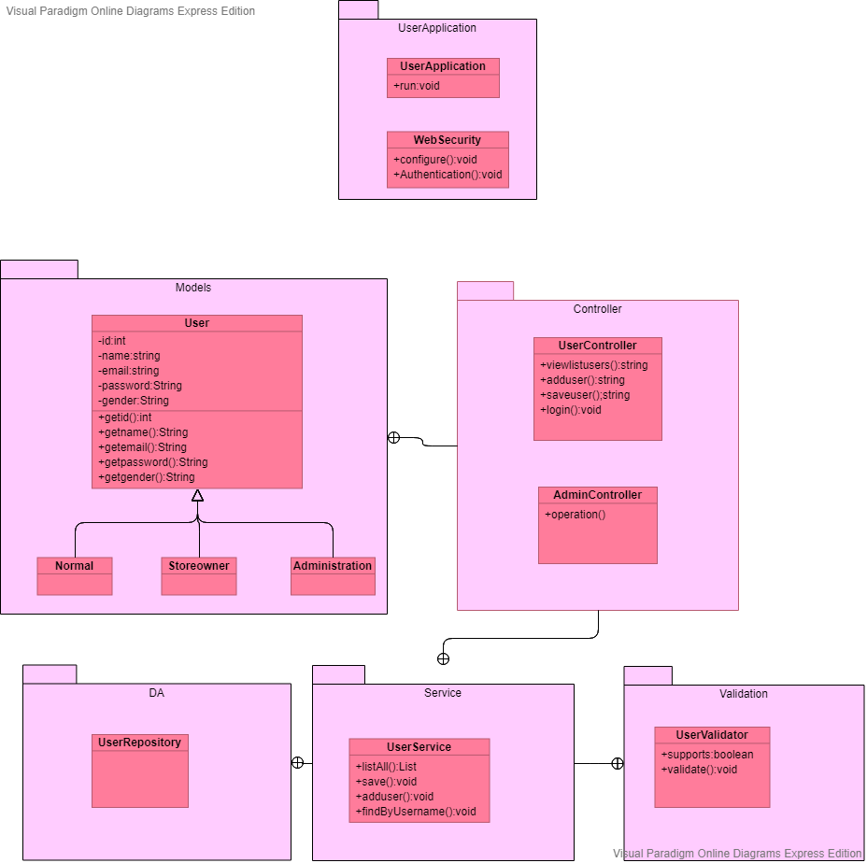

# 

# Sequence diagram **Administartion.vpdLoginSignUp**

# Github repository link

<https://github.com/alaafar256/SoftwareEngineering2Project>